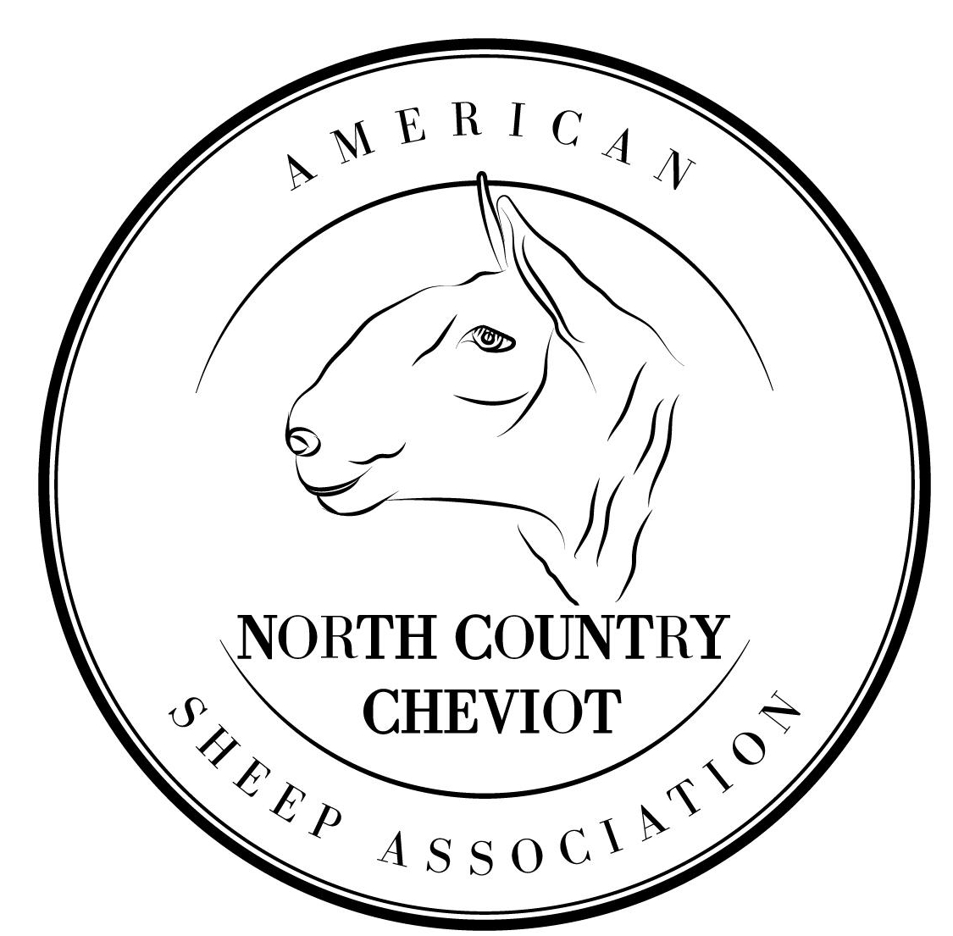

American
North Country Cheviot
Sheep Association
Young Shepherd’s Award

The American North Country Cheviot Sheep Association (ANCCSA) recognizes and values our youth. Funds have been set aside to assist youth in becoming future North Country Cheviot breeders. The intent of these funds are to create starter flocks, develop breeding skills, promote agriculture, and increase involvement in breeding and raising sheep, particularly North Country Cheviot.

Two $400 awards have been set aside for youth. One award will be awarded to an individual for each age group (9-13 and 14-19) as of January 1st. Interested applicants must meet the below requirements and submit their application by April 15th to allow for judging of applications to occur before the National Sale. Winners will be announced in May.

Award Requirements:
- Applicants must be between age 9-13 or 14-19.
- Applicants must appoint a mentor, preferably a North Country Cheviot sheep producer. Mentors may include relatives, neighbors, 4-H/FFA Leader, or other sheep producer.
- Award recipients must use the award to purchase a North Country Cheviot sheep from a sponsored ANCCSA sale or from an active, non-related ANCCSA member. Payment will be made directly to the seller or sale host.
- One letter for recommendation from a 4-H/FFA Leader or sheep producer testifying the applicant's ability to build and raise a sheep flock is required.
- The award must be used within a year of presentation.

Submit completed application forms to address below or by email (mike.cheviot@gmail.com). All applications must be postmarked no later than April 15th.

Michael Romanski
American North Country Cheviot Sheep Association
15343 Curtis Ave NW
Monticello, MN 55362

American North Country Cheviot Sheep Association
Youth Shepherd’s Award

Name:__________________________________________________________________

Age as of January 1st:________ Current Age: ________ Date of Birth: _______________

Address: _______________________________________________________________

E-mail Address: __________________________________________________

Phone: ________________________________

Years of 4-H and FFA Experience_________________

School Currently Attending: ______________________________________________________

Year of High School Graduation: __________

Mentor:______________________________________________________________________

Mentor Address: ______________________________________________________________

Mentor Phone: ________________________________________________________________

Applicant’s Signature: _________________________________________ Date: ________________

Parents Signature (If under 18) :_________________________________ Date: ________________

Please, answer the following questions completely. Attach additional pages as needed.

1.) Begin by letting us know why you are interested in raising North Country Cheviot sheep? (20 points)

2.) Tell us about the experiences you have learned from working with livestock and include your 4-H and FFA projects. (20 points)

3.) If you receive this award, how do you plan on using it? (20 points)

4.) What are your educational plans and career goals? (15 points)

5.) Pick ONE of the two following topics to write about and explain in 100-300 words. (25 points)
(5-1) Looking towards the future, explain and describe how you might be involved in the breeding and promotion of North Country Cheviot Sheep.

(5-2) What values will owning North Country Cheviot sheep instill in you?

